MAPS AND DIRECTIONS
BURNABY LAKE

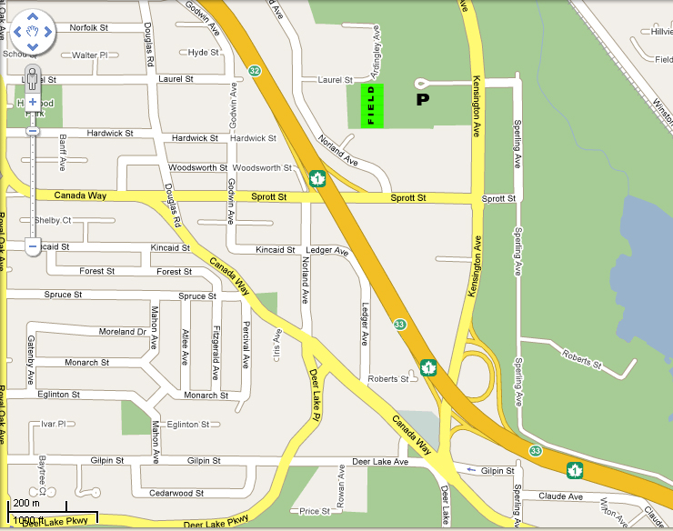

Burnaby:  Burnaby Lakes Park  Kensington Ave, Bby | - Go North on King George Highway.  - Go over Patulla Bridge and continue on McBride  - Turn Left (West) on 10th Ave  - Turn Right (North) on Canada Way  - Turn Right (North) on Kensington Ave - Go over #1 hwy  - Turn Left (West) on Joe Sakic Way

MAPS AND DIRECTIONS
CHILLIWACK TOWNSEND PARK

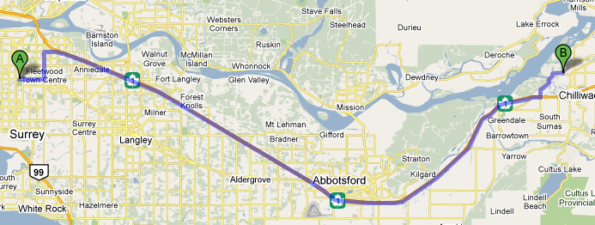

Chilliwack:  Townsend Park | - Head east on 88 Ave E toward 138a St  - Turn left at 152 St  - Turn right at 104 Ave  - Take the ramp onto BC-1 E  - Take exit 116 for Lickman Road N  - Turn left at Lickman Rd  - Continue onto Chilliwack Mountain Rd  - Turn right at Schweyey Rd  - Schweyey Rd turns slightly right and becomes Wolfe Rd Destination will be on the right  - Alternate route is Or take exit 118 or exit 119 will take you directly to the park
MAPS AND DIRECTIONS
CLOVERDALE ATHLETIC PARK

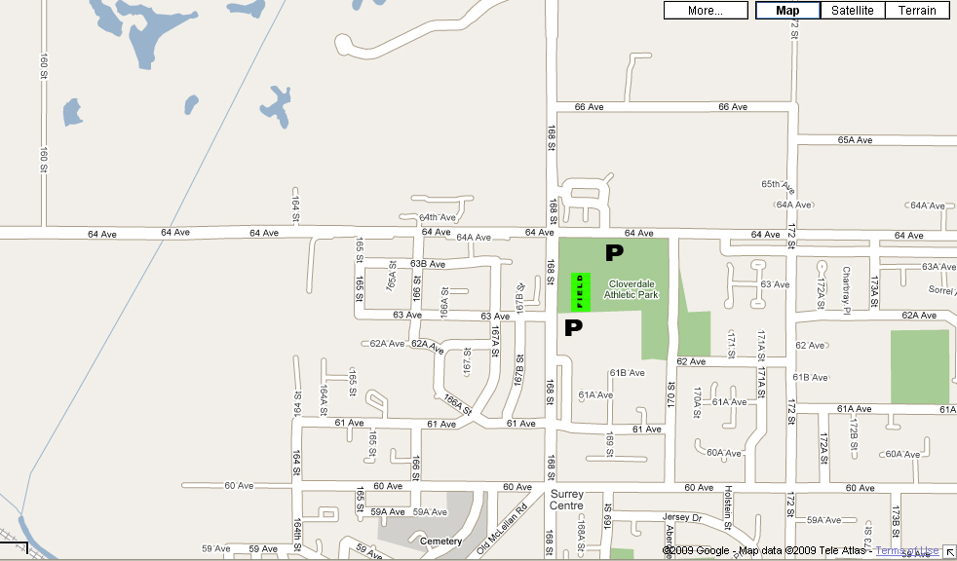

Cloverdale:  Cloverdale Athletic Park  64th Avenue and 168th Street, Surrey | - Go South on King George Highway.  - Turn Left (East) on 64th.  - Turn Right (South) on 168th and enter parking lot from west side of park

MAPS AND DIRECTIONS
COQUITLAM MACKIN PARK

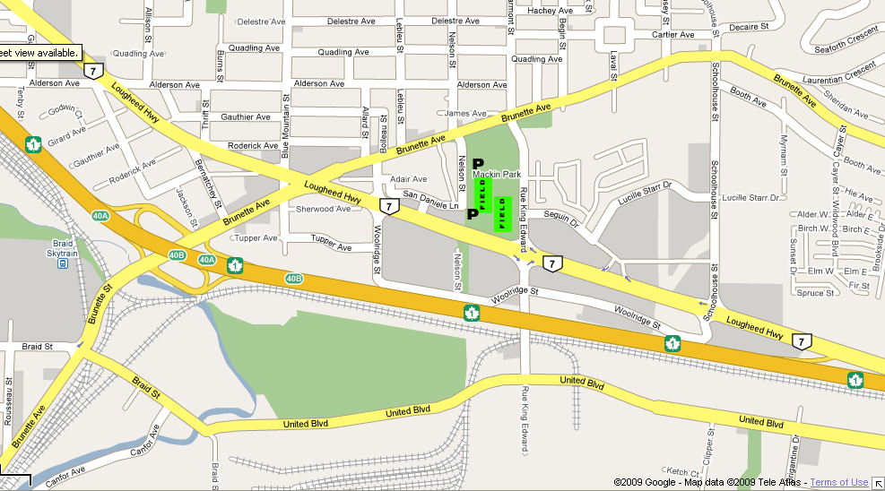

Coquitlam (Main Fields):  Mackin Park North and South  Lougheed Hwy & Nelson  Coquitlam | - Go East on 88th Ave to 152nd  - Turn Left on 152nd and go over Port Mann Bridge on #1 Highway  - Take Brunette exit and turn Right on Brunette.  - Turn Right on Nelson to parking lot

MAPS AND DIRECTIONS
COQUITLAM TOWN CENTRE

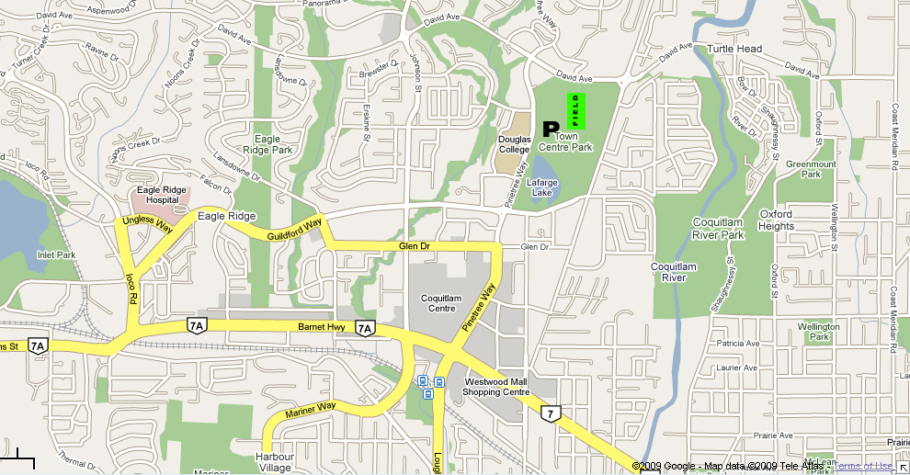

Coquitlam (Night Games):  Town Center | - Go East on 88th Ave to 152nd  - Turn Left on 152nd and go over Port Mann Bridge on #1 Highway  - Take #7 Lougheed Exit.  - At the intersection of Lougheed and Barnett where Coquitlam Center is  continue straight through lights onto Pinetree Way.  - Turn Right on Pinewood Ave to parking lot.

MAPS AND DIRECTIONS
COWICHAN McADAM PARK

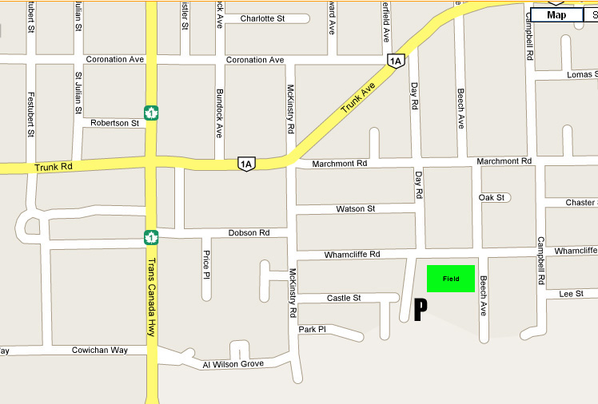

Cowichan:  McAdam Park  Wharncliff Road and Day road Duncan | - From Nanaimo Ferry Terminal go south on Highway #1  - Turn Left (East) on Trunk Road.  - Turn Right (South) on McKinstry.  - Turn Left (East) on Wharncliffe

MAPS AND DIRECTIONS
LANGLEY CITY PARK

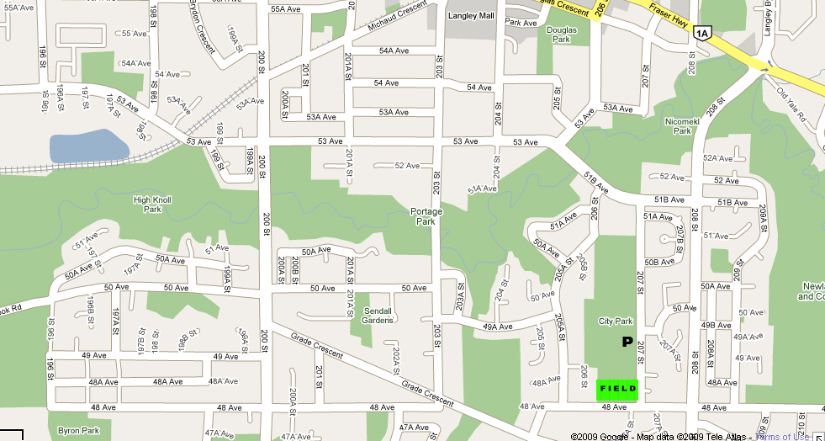

Langley: (Main Field)  Langley City Park  48th Avenue & 207th Street | - Go East on 88th Ave to Fraser Highway.  - Turn Right (South East) on Fraser Highway.  - Turn Left on Highway 10.  - Follow Langley By-Pass around and continue straight on what becomes  208th .  - Turn Right (West) on 48th Ave.

MAPS AND DIRECTIONS
LANGLEY McLEOD PARK

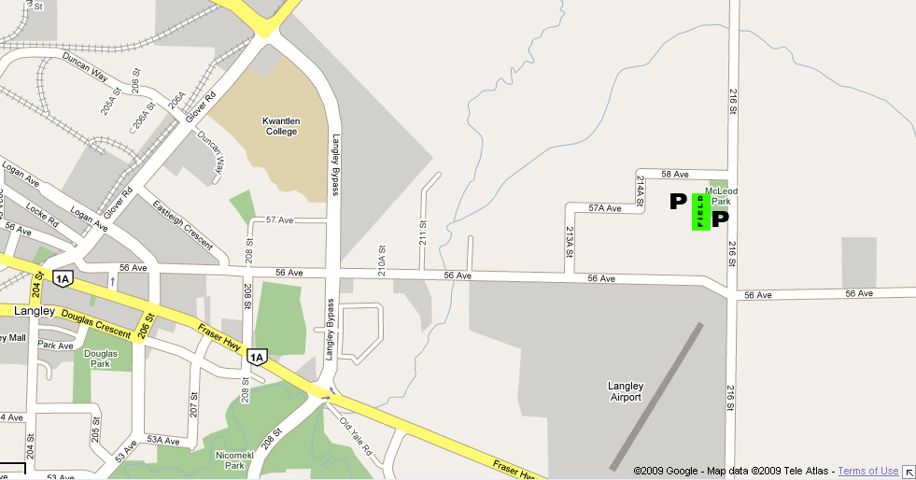

Langley: (Night Games)  McLeod Park  56th Avenue & 216th Street | - Go East on 88th Ave to Fraser Highway.  - Turn Right (South East) on Fraser Highway.  - Turn Left on Highway 10.  - Follow Langley By-Pass around and continue straight on what becomes  208th .  - Turn Left (East) on 568th Ave.  - Turn Left (North) on 216th St.

MAPS AND DIRECTIONS
MAPLE RIDGE SAMUEL ROBERTSON TECH SCHOOL

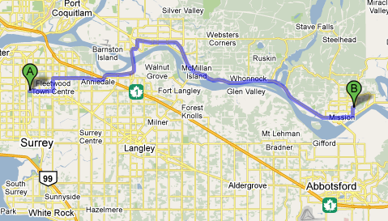

Maple Ridge:  Samuel Robertson Tech | - Head east on 88 Ave E toward 138a St  - Turn left at 152 St  - Turn right at 96 Ave  - Continue onto Golden Ears Way  - Partial toll road  - Take the 113B Avenue exit toward Airport Way  - At the roundabout, take the 1st exit onto 113b Ave  - Continue onto 203 St  - Turn right at Lougheed Hwy/BC-7 E  - Turn left at 240 St  - Turn right at 104 Ave  - Take the 1st left onto 245 St (10445)
MAPS AND DIRECTIONS
MISSION HERITAGE PARK

Mission:  Heritage Park | - Head east on 88 Ave E toward 138a St  - Turn left at 152 St  - Turn right at 96 Ave  - Continue onto Golden Ears Way - Partial toll road  - Take the 113B Avenue exit toward Airport Way  - At the roundabout, take the 1st exit onto 113b Ave  - Continue onto 203 St  - Turn right at Lougheed Hwy/BC-7 E  - Turn left at Horne St/Lougheed Hwy/BC-7 E  - Turn right at 1 Ave/Lougheed Hwy/BC-7 E (signs for Abbotsford)  - Turn left at Stave Lake St  - Turn right at Prentis Ave (33770 Prentis Ave)
MAPS AND DIRECTIONS
NANAIMO PIONEER PARK

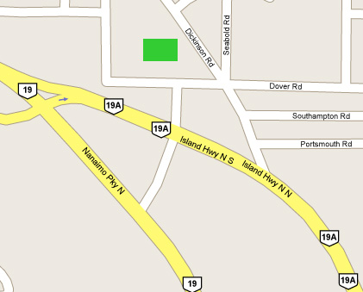

Nanaimo:  Pioneer Park | - From Nanaimo Ferry  - Go North on Highway #1.  - Take Nanaimo Bypass.  - Near end of Bypass take Mary Ellen Road (North East).  - Turn Left (West) on Dover.

MAPS AND DIRECTIONS
NEW WESTMINSTER MERCER STADIUM

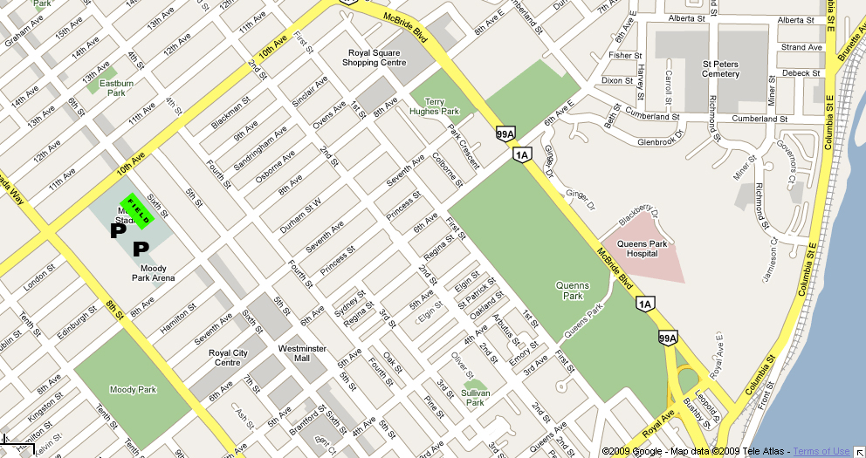

Royal City Hyacks  (New Westminster):  Mercer Stadium  10th Street and 6th Avenue | - Go North on King George over the Pattullo Bridge.  - This turns into McBride.  - Turn Left (North) on 10th Avenue and go to 8th Street.  - Turn Left (West) on 8th Avenue. Parking Log off 8th.

MAPS AND DIRECTIONS
NORTH DELTA JOHN OLIVER PARK

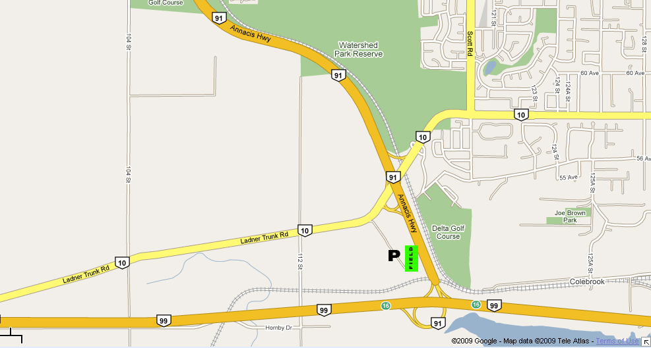

North Delta:  John Oliver Park  Hwy 10, between  Hwy 91 & 99 | - Go South on King George Highway.  - Turn Right (West) on 64th Ave.  - Turn Left (South) on 120th Street.  - Turn Right (West) on Highway #10.  - Go over Highway #91 and just after exit to #91 turn left (South)  at park entrance

MAPS AND DIRECTIONS
NORTH SHORE CONFEDERATION PARK

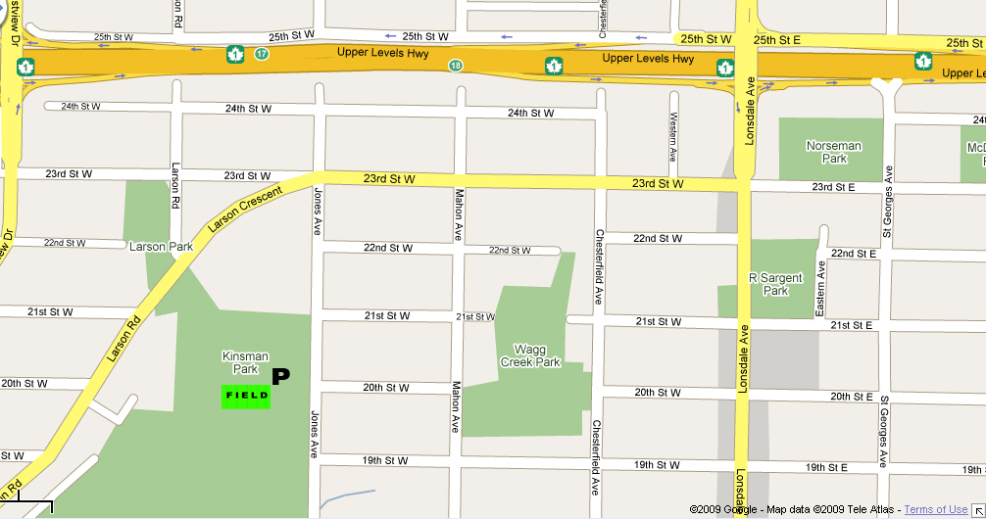

North Shore:  Confederation Park  2145 Jones Ave  North Vancouver | - Go West on 88th Ave  - Take Alex Frasier Bridge (North)  - Take Queensburough Bridge (North)  - Stay in Left lane and take Marine Drive West exit  - Travel West on Marine Drive  - Turn Right (North) on Willington  - Take #1 West Exit  - Take Lonsdale Exit  - Turn Left (South) on Lonsdale  - Turn Right (West) on 23rd Ave.  - Turn Left (South) on Jones

MAPS AND DIRECTIONS
NORTH SHORE WILLIAM GRIFFEN PARK

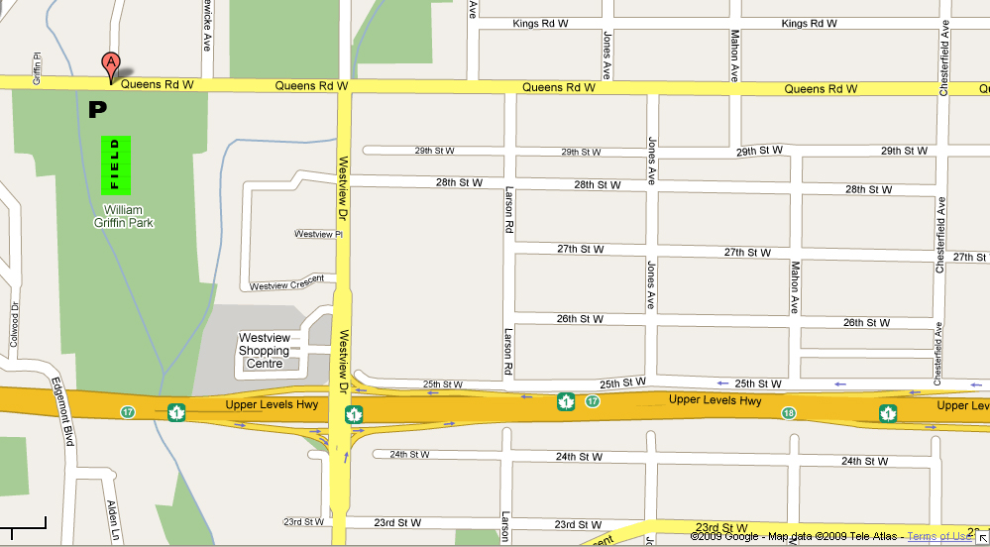

North Shore:  William Griffen Park | - Go West on 88th Ave  - Take Alex Frasier Bridge (North)  - Take Queensburough Bridge (North)  - Stay in Left lane and take Marine Drive West exit  - Travel West on Marine Drive  - Turn Right (North) on Willington

MAPS AND DIRECTIONS
RICHMOND McNAIR PARK

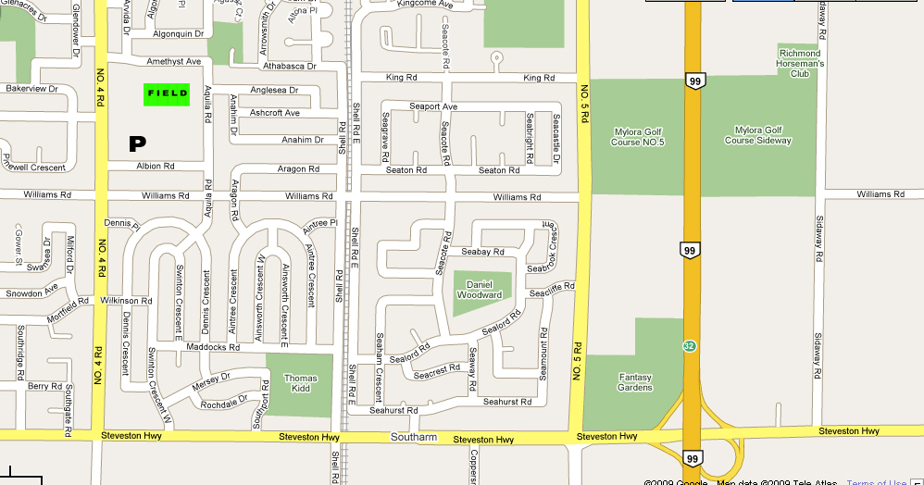

Richmond (Day Games):  McNair Park  On No. 4 Road, north of Williams Road | - Go West on 88th Ave to Highway #91.  - Take right exit (North) onto Highway #91 North.  - Take Richmond Connector (left lane over Alex Fraser Bridge).  - Go into Richmond and turn Left (South) on #4 Road.  - Turn Left onto either Albion (main parking) or Amethyst (walk through to field)

MAPS AND DIRECTIONS
RICHMOND MINORU PARK

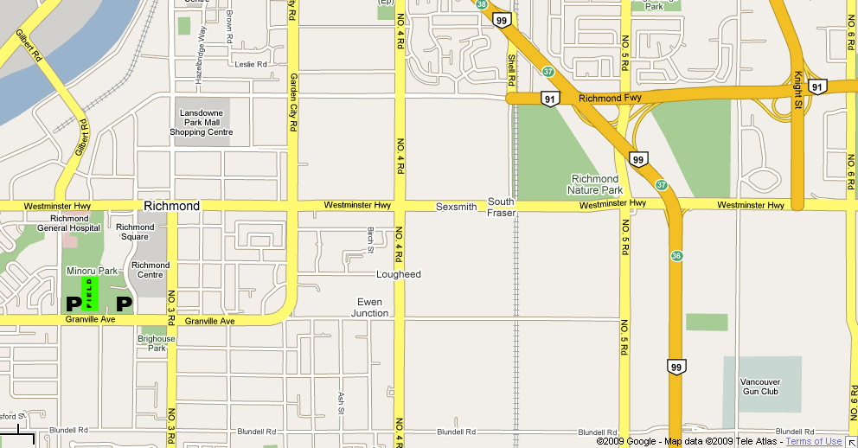

Richmond (Night Games):  Minoru Stadium | - Go West on 88th Ave to Highway #91.  - Take right exit (North) onto Highway #91 North.  - Take Richmond Connector (left lane over Alex Fraser Bridge).  - Go into Richmond and turn Left (South) on Garden City Road.  - Garden City curves around into Grandville

MAPS AND DIRECTIONS
SOUTH DELTA DENNISON PARK Tsawassen

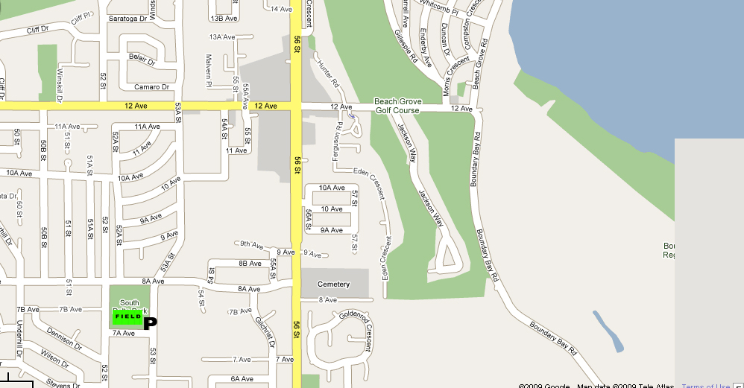

South Delta:  Dennison Park  8A and 53rd  Tsawassen | - Go South on King George Highway.  - Turn Right (West) on 64th Ave.  - Turn Left (South) on 120th Street.  - Turn Right (West) on Highway #10.  - Go over Highway #91 and over Highway #99 until Highway #17.  - Turn Left (South) on Highway #17.  - Turn Left (East) on 56th Ave.  - Turn Right (South) on 8a Ave.  - Turn Left (East) on 53rd St.

MAPS AND DIRECTIONS
SQUAMISH DON ROSS SECONDARY

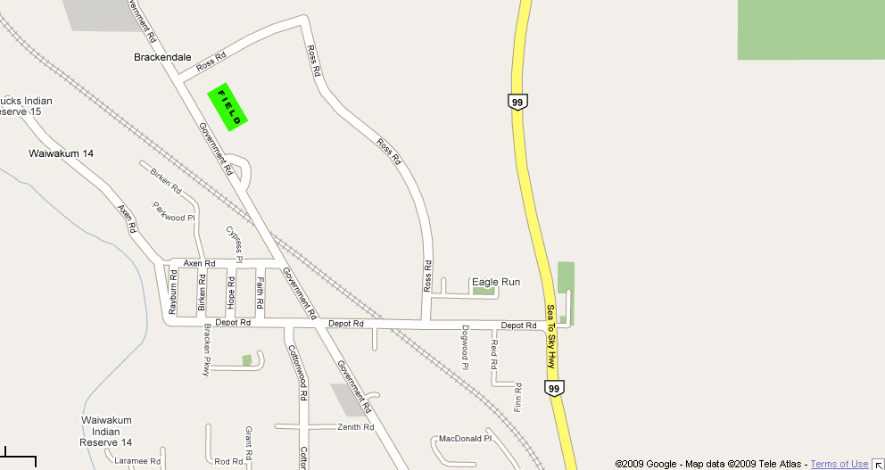

Squamish:  Don Ross Secondary  42091 Ross,  Brackendale (Squamish), BC | - Take Hwy 1 West

MAPS AND DIRECTIONS
VANCOUVER RUPERT PARK

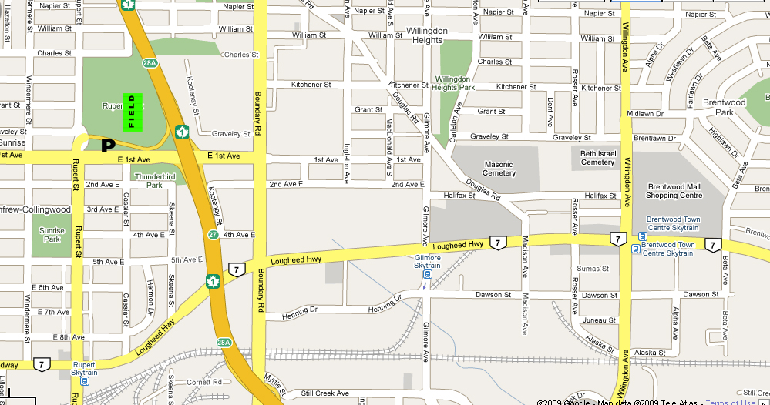

Vancouver Trojans:  Rupert Park  1st Ave and Rupert | - Go East on 88th Ave. to 152nd.  - Turn Left (North) on 152nd.  - Continue onto Highway #1.  - Take 1st Avenue Exit and turn Left (West) on 1st Ave.  - Turn Right into the park.

MAPS AND DIRECTIONS
VANCOUVER CARNARVON PARK

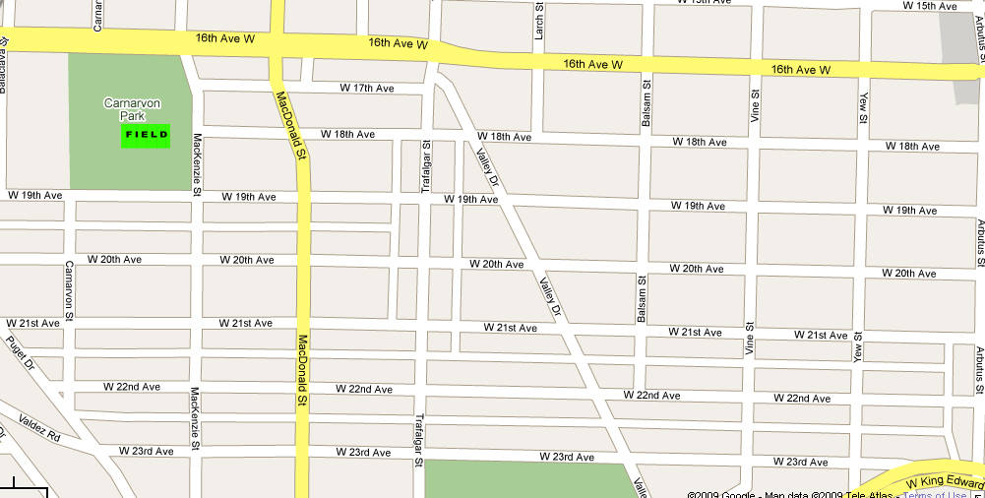

Westside:  Carnarvon Park  16th Avenue & MacKenzie  Vancouver | - Go East on 88th Ave. to 152nd.  - Turn Left (North) on 152nd.  - Continue onto Highway #1.  - Take Grandview Highway Exit.  - Grandview turns into 12th.  - Turn Left on Arbutus (South).  - Turn Right (West) on 16th.

MAPS AND DIRECTIONS
VICTORIA GORDON HEAD Saanich

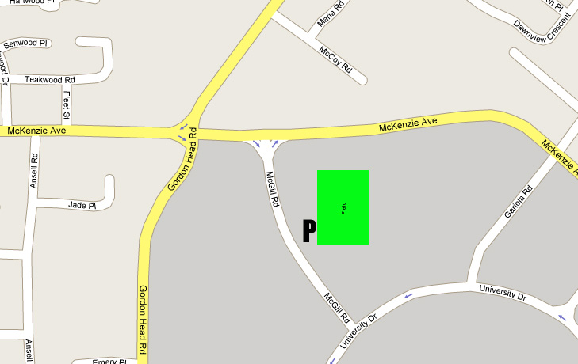

Greater Victoria Warriors:  3957 Gordon Head Rd,  Saanich | - Drive off Ferry.  - Continue down Highway.  - Take McKenzie Street Exit.  - Turn Left (East) on McKenzie Street.  - Turn Left (North) on Gordon Head Road.

MAPS AND DIRECTIONS
WHITE ROCK SOUTH SURREY ATHLETIC PARK

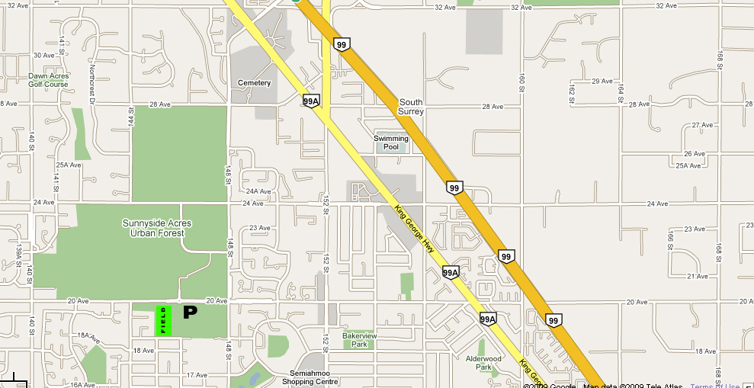

White Rock South Surrey:  South Surrey Athletic Park  148th St & 20th Ave  White Rock | - Go South on King George.  - Turn Right (South) on 148th Street.  - Turn Left (West) on 20th Avenue.  - Field is on the Left (South) side.

